AWS Module 2 | IAM

# Introduction

This document provides evidence for proper completion of AWS module 2 on IAM. The two main features are:

* IAM User generation via a script to illustrate automation.
* Establishing an MFA policy

# User Generation

The script, aws-iam-create-user.sh, reads rows from a csv file containing the user information to import into IAM. The columns in the csv file are user, group and password.

The script iterates over the rows in the csv file. The following aws iam commands generate the IAM users:

* aws iam create-user --user-name $user
* aws iam create-login-profile --password-reset-required --user-name $user --password $password
* aws iam add-user-to-group --group-name $group --user-name $user

## CSV File

The csv file consists of 4 users.

## Script Execution

The script takes the csv filename as a parameter.   
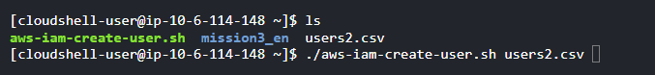

## The following is an excerpt of the output of the script execution.

# Multiple Factor Authentication (MFA)

The Multiple Factor Authentication is established through a custom policy, entitled EnforceMFAPolicy. The custom policy is created using the json file, force_mfapolicy.json.

MFA uses Google Authenticator on my cell. MFA is configured for the root user and at least one IAM User.

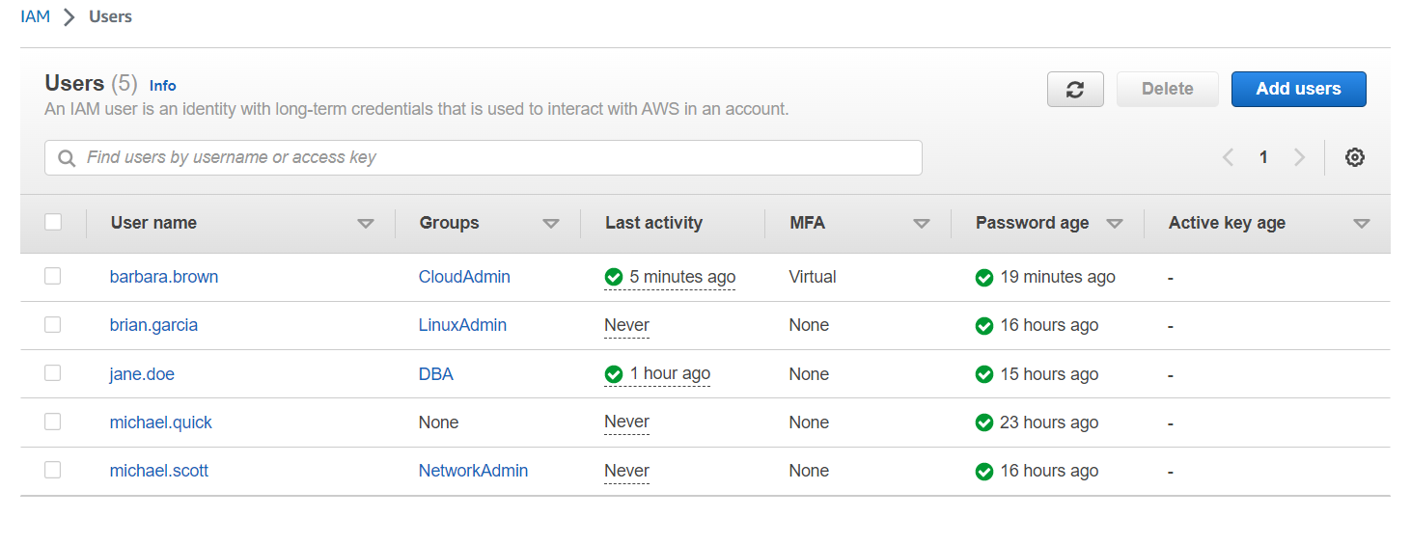

## Account Settings

A custom password policy is established.

## Group Permission Policies

Each User Group has its own permission policies. Every User Group contains the EnforceMFAPolicy permission policy.

